SOFTWARE PACKAGE DEVELOPMENT

ONLINE STREAMING PLATFORM

ABSTRACT:

In recent years, the Web has undergone a tremendous growth regarding both content and users. This has led to an information overload problem in which people are finding it increasingly difficult to locate the right information at the right time. Recommender engines, also known as recommender systems, are software tools that have been developed to address this problem, by guiding users through the big ocean of information and suggesting them to make decisions on what movie to watch, what item to purchase and what articles to read.This abstract studies the feasibility of the integration of a recommender engine as a module to the online streaming platform. It mines movie databases to collect all the important information, such as, popularity and attractiveness, required for recommendation. It generates movie swarms not only convenient for movie producers to plan a new movie but also useful for movie recommendation.Prior to the design of the application and the decisions made at the design stage, this document shows the analysis of the requirements for the recommender system in the context of the business.

REQUIREMENTS STUDY:

Functional Requirements:
The functional requirements critical for the performance of the streaming platform

- Build a good recommendation system based on user interest.
- Feature to allow users to create accounts.
- Allow users to customize their profiles.
- Allow users to handle multiple accounts.
- Allow users to watch videos.
- Let developers upload video from the backend and make it available on the platform.
- Allow content search for users to select different content genres.
- Allow users to have a private streaming through the platform and allow chatting with other users.
- Multiple language support.
- Admin panel support to allow the main user to have access to all content to manage videos and users (block users if necessary).

Non-functional Requirements:

The non-functional requirements critical for the performance of the streaming platform

- There should be no buffering, i.e., provide users with real-time video streaming without any lag.
- Accurate System - The server application shall produce accurate recommendations
- High Availability
- Scalability - The recommender system shall have the potential of being scalable both with respect to size and geography
- Excellent connectivity - users should be able to watch videos without any slowdown or disruptions.
- High Bandwidth - To allow you to broadcast high resolution videos.
- CyberSecurity - Security measures are needed to prevent the chances of intruders
- Reliable storage - Robust storage capacities for streaming video services is essential. A reliable public cloud repository like Amazon web services clouds be chosen for streaming video applications.
- Payment Gateway.
PROCESS MODEL - SPIRAL MODEL
The process model we have chosen to use is a spiral model of development. This is best suited for our package due to various reasons such as:
- Updation & creation of a new system
- Medium to large in size
- Involves various stages
- Needs risk & error management
- Must achieve a milestone in each cycle
- Long-term project commitment because of potential changes to economic priorities as the requirements change with time.
- Requirements are complex and need evaluation to get clarity.
- New product line which should be released in phases to get enough customer feedback.
- Significant changes are expected in the product during the development cycle
SPIRAL MODEL - DESIGN
The spiral model has four phases. A software project repeatedly passes through these phases in iterations called Spirals.

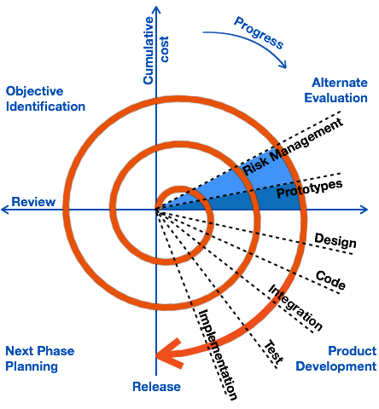

Identification:
This phase starts with gathering the requirements in the baseline spiral. In the subsequent spirals as the platform matures, identification of system requirements, subsystem requirements and unit requirements are all done in this phase.
This phase also includes understanding the system requirements by continuous communication between the customer and the system analyst. At the end of the spiral, the product is deployed in the identified market.

Design:
The Design phase starts with the conceptual design in the baseline spiral and involves architectural design, logical design of modules, physical product design and the final design in the subsequent spirals.

Construct or Build:
The Construct phase refers to production of the actual software product at every spiral. In the baseline spiral, when the product is just thought of and the design is being developed a POC (Proof of Concept) is developed in this phase to get customer feedback.
Then in the subsequent spirals with higher clarity on requirements and design details a working model of the software called build is produced with a version number. These builds are sent to the customer for feedback.

Evaluation and Risk Analysis:
Risk Analysis includes identifying, estimating and monitoring the technical feasibility and management risks. After testing, at the end of the first iteration, the customer evaluates the software and provides feedback.

FEASIBILITY STUDY:

Operational feasibility:

- The project will be implemented in a way that it will allow the functioning of recommendations smoothly.
- It will provide a user-friendly user interface in a modular fashion.
- The user only requires the latest versions of Chrome or Mozilla Firefox to run this application.
- No paid software or new technologies are to be availed by the user.

Economic Feasibility :

- The software being used in this project is completely open-source and available to everyone for use.
- To name a few, web development frameworks, python packages, etc. are all open to be used by the general public. These are also commonly supported by free browsers that are easily downloadable from the internet.
- The Recommended system that we are developing economically from the user’s point of view. It is cost-effective because it has eliminated any hustle completely. The system is also time effective because most of the work is automated .

Technical feasibility:
The technical requirements for this R.S. are economic and it does not require any additional software or hardware.

Tools and Libraries required:
- Python - 3.x
- Pandas - 1.2.4
- Scikit-learn- 0.24.1

Hardware requirements:
- Windows based computer system

Keyboard

Mouse

RAM of 512 MB or above
- HardDisk 10 GB or above

Software requirements:
- Node js
- React
- Javascript
- Html
- CSS
- Expressjs
- Google Chrome v27.0.1453.116m or higher.

Database to be used:
- Firestore

